*Project report*

**machine learning**

submitted by :habibullah (10591)

submitted to :sir sharraf Hussain

**Model :**

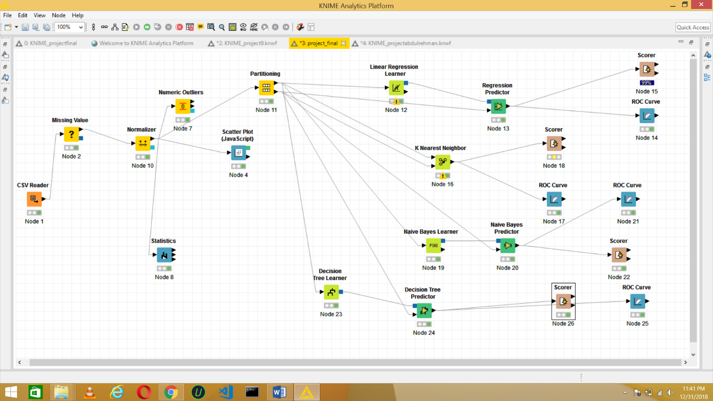

**Error Based Learning**

* **ROC of Linear Regression**

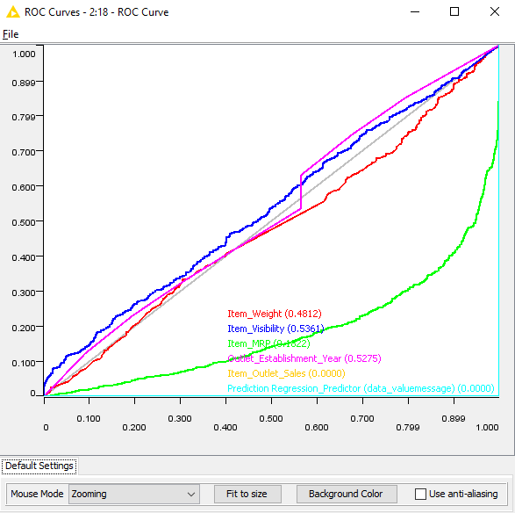

* **Confusion Matrix of Linear Regression**

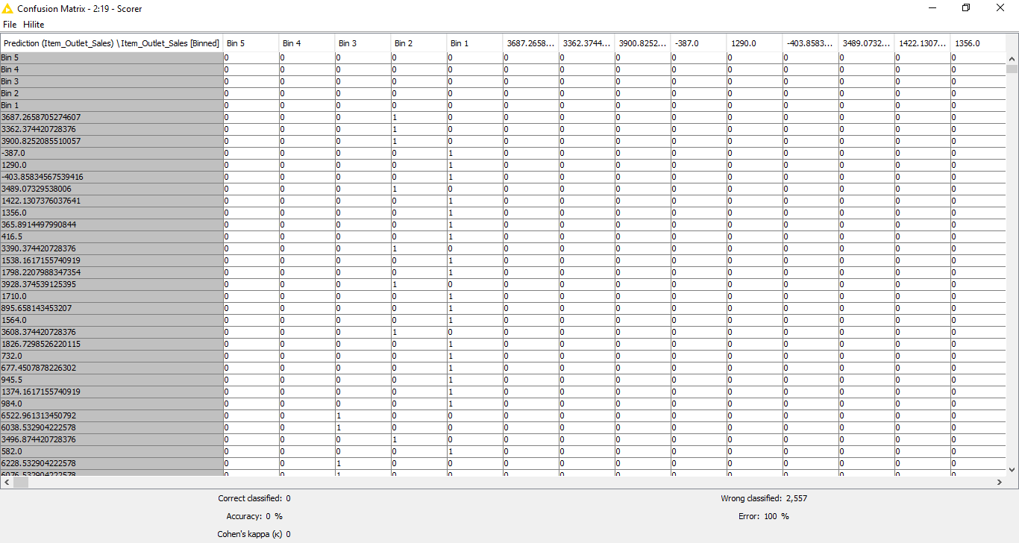

**Probability Based Algorithms**

* **ROC of Naive Bayes**

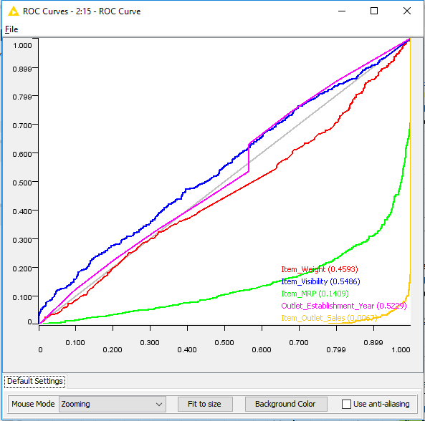

* **Confusion Matrix of Naive Bayes**

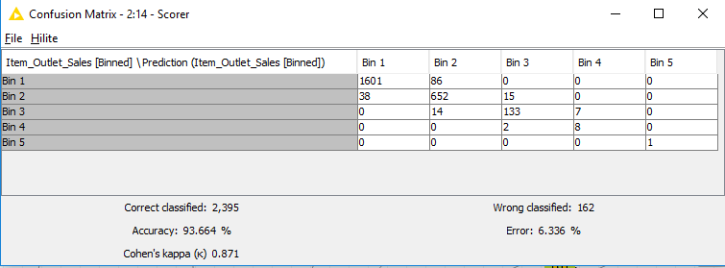

**Similarity Based Algorithms**

* **ROC curve of K-Nearest Neighbor**

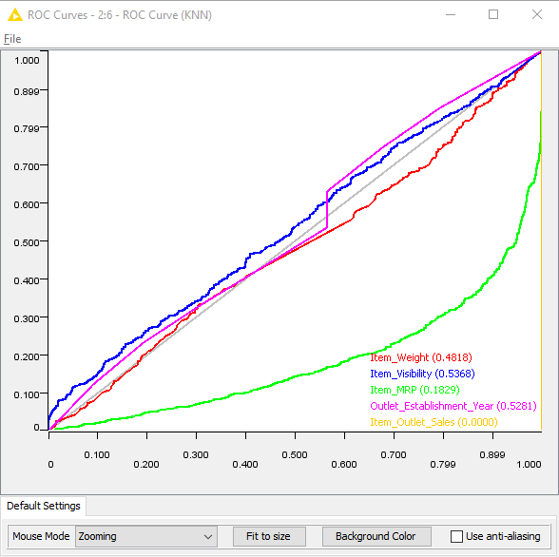

* **Confusion Matrix of K-Nearest Neighbor**

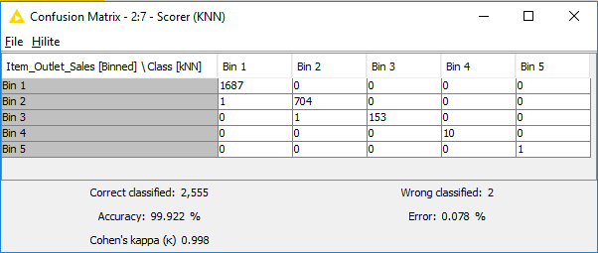

**Information Base Learning**

* **ROC Curve of Decision Tree**

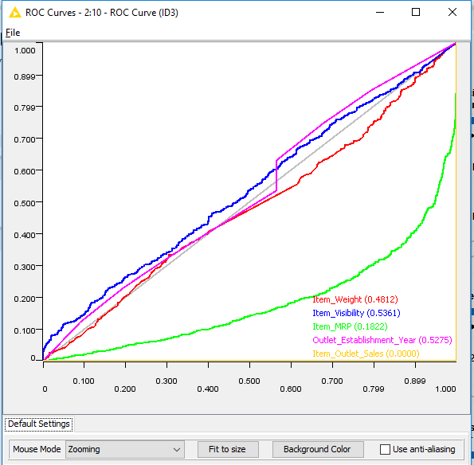

* **Confusion Matrix of Decision Tree**

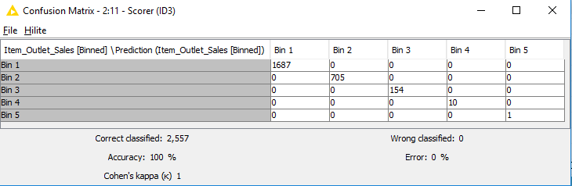

# **Results**

Out of all four algorithms applied, Decision Tree of Information Gain and KNN of Similarity Based Learning gave the best prediction and 0.00 ROC Curve with Accuracy of above 90%. Hence, these two performed the best with the dataset of the above-mentioned business problem.